# More Exercises: CSS Selectors and Rules

Problems for exercises and homework for the ["HTML and CSS" course @ SoftUni](https://softuni.bg/courses/web-fundamentals-html5). Submit your solutions in the SoftUni judge system at <https://judge.softuni.bg/Contests/798/CSS-Selectors-Rules-In-Depth-More-Exercises>.

## Potato

You are given the HTML for the following Web page. Write the missing CSS:

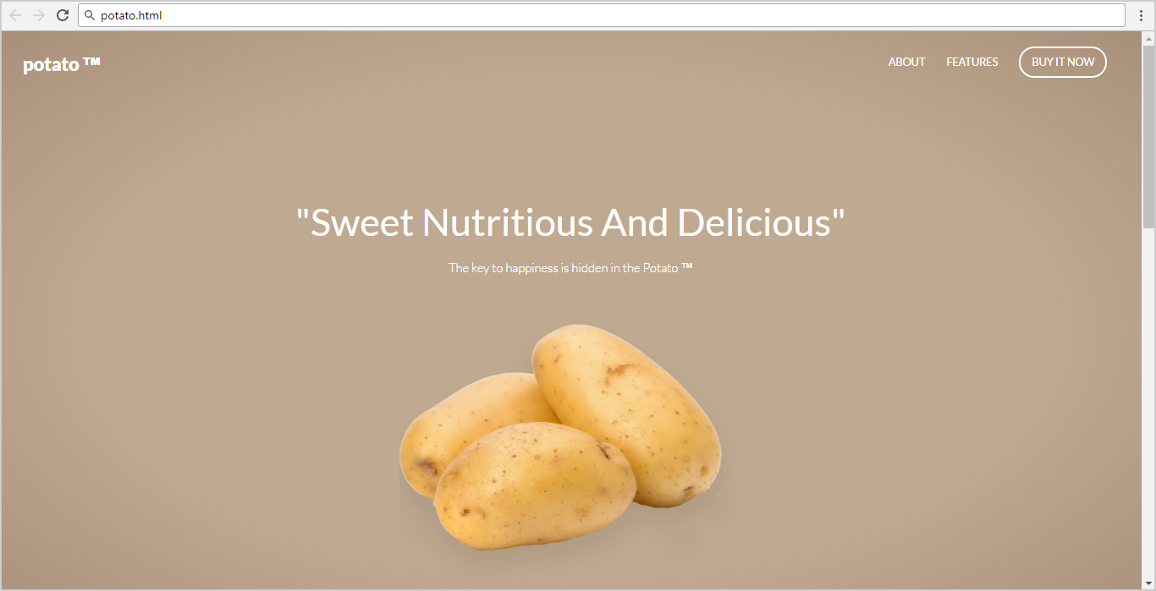

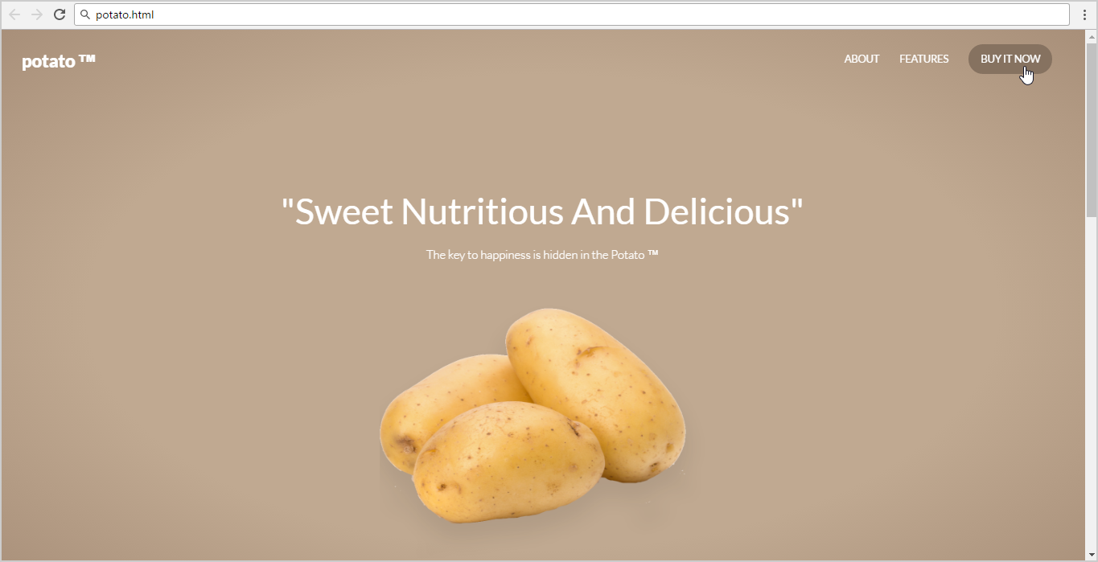

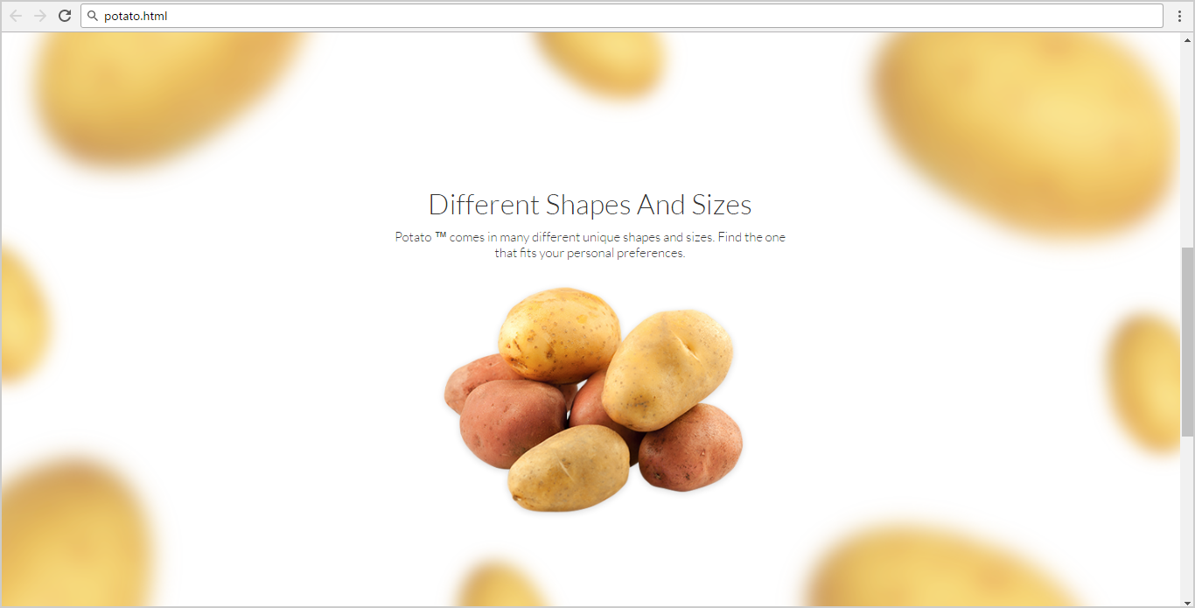

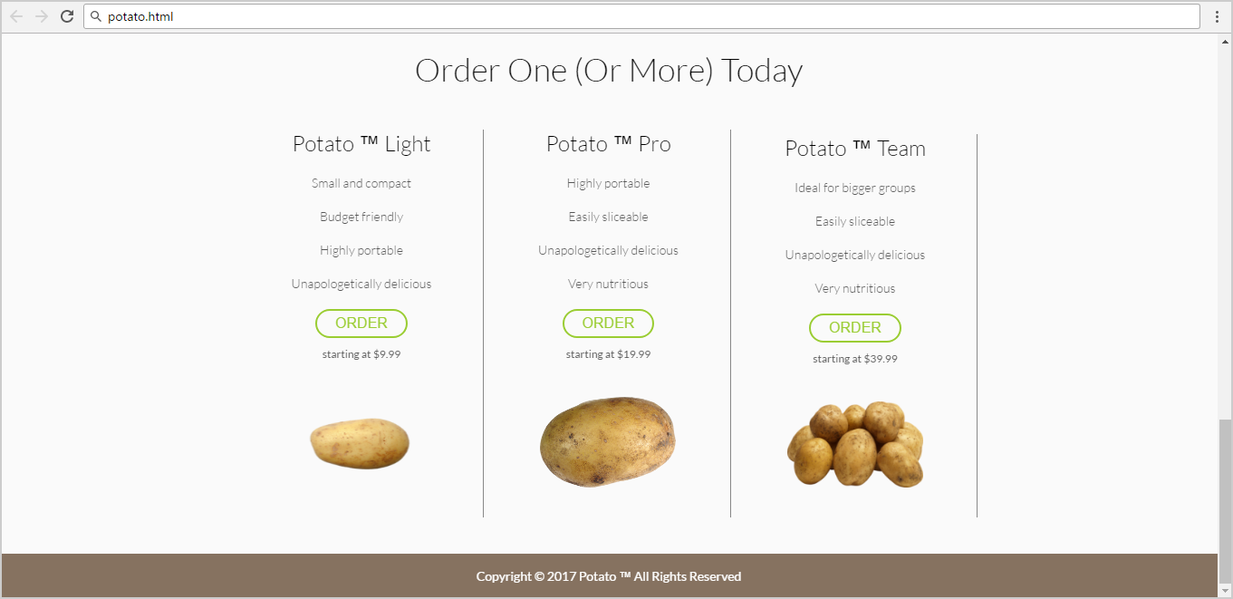

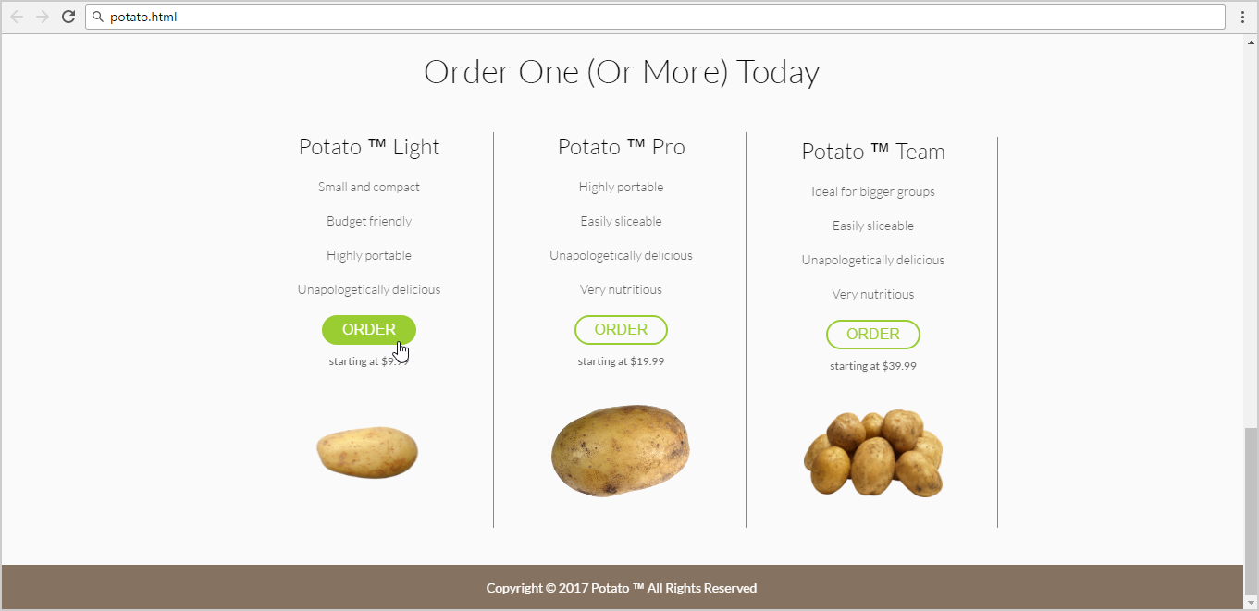

* Use the following HTML file as starting point: "**potato.html**".
  + You are **NOT** allowed to change the HTML code.
* Create the missing CSS file: "**potato.css**".

### Constraints

* Default font: 14px 'Lato', sans-serif;

### Hints

Use a **color picker** to catch certain colors.

Use for <header>

* background: **radial-gradient(ellipse at center,**

**rgba(192,169,145,1) 0%,  
 rgba(192,169,145,1) 59%,  
 rgba(168,143,121,1) 100%);**

## Japanese Kitchen

You are given the HTML for the Web page shown below. Write the missing CSS:

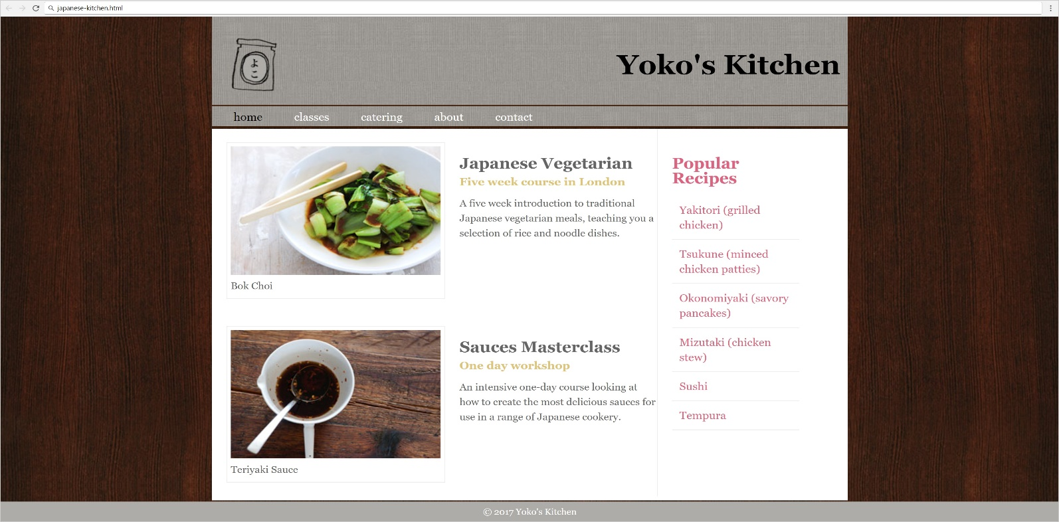

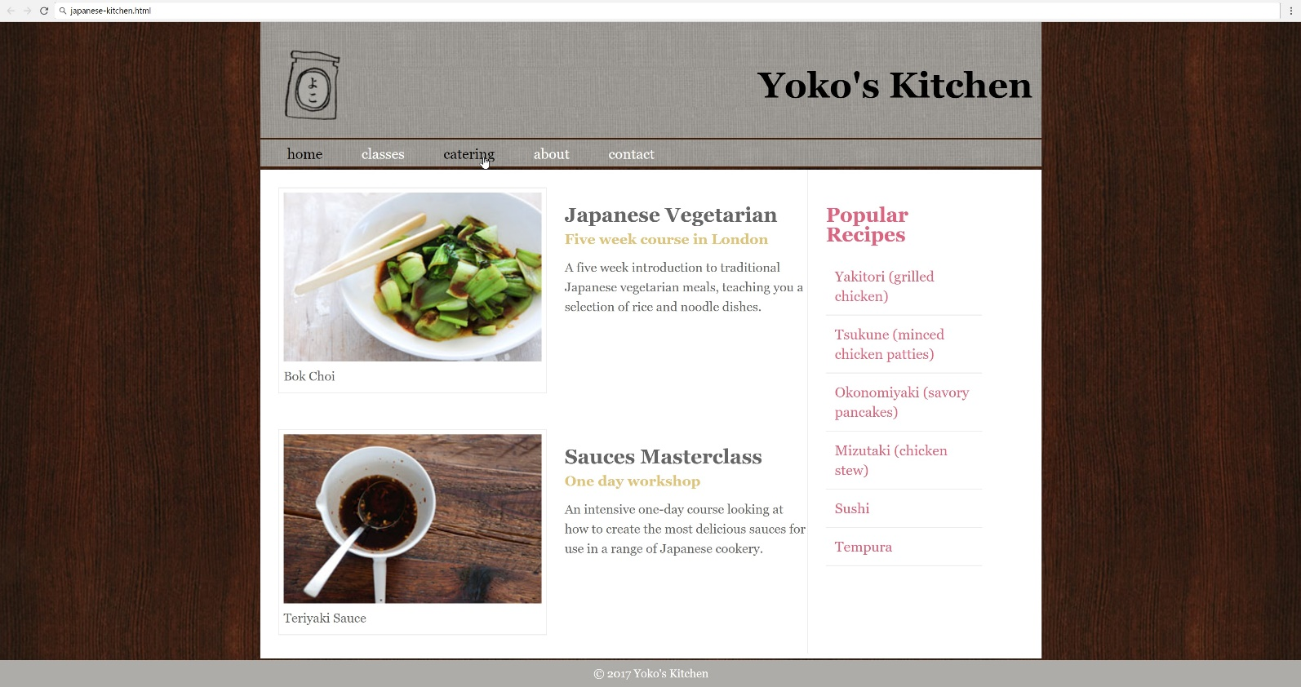

* Use the following HTML file: "japanese-kitchen.html".
  + You are **NOT** allowed to change the HTML code.
* Create the missing CSS file: "japanese-kitchen.css".

### Constraints

* **Reset** **CSS styles** at the start of your CSS.
* Default font: 14px 'Lato', sans-serif;